# Lab 02: Working with R Studio and R Markdown

1. Open the online server of RStudio by going to:

Rstudio.lawrence.edu

1. Log in with your LU credentials
2. File/New File/R Markdown

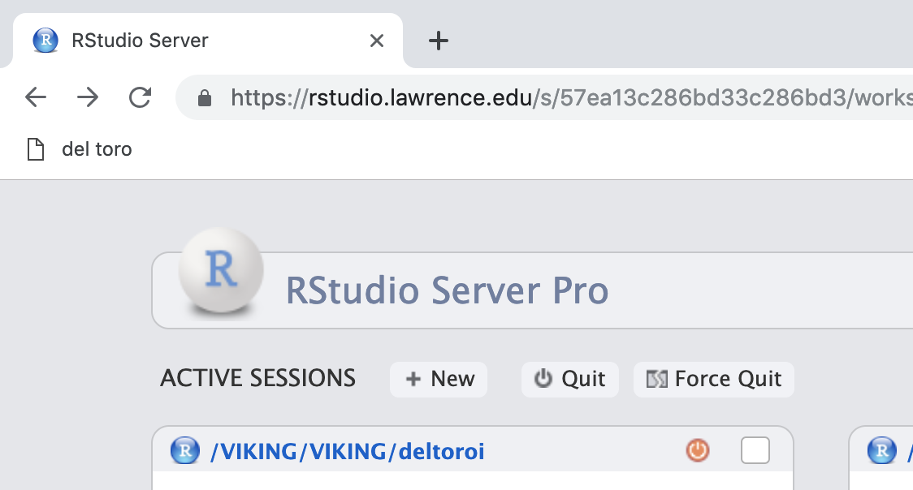

1. Upload the blank Lab 2 template:
   1. Download the .RMD file from Moodle/Lab1 (the file will most likely download to your “downloads” folder unless otherwise specified
   2. Go to “Upload” in the “files” tab of the bottom right window.

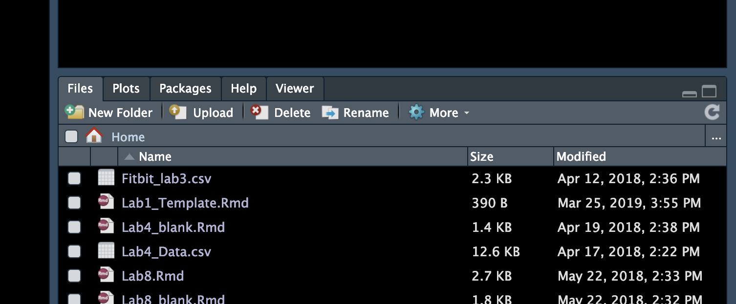 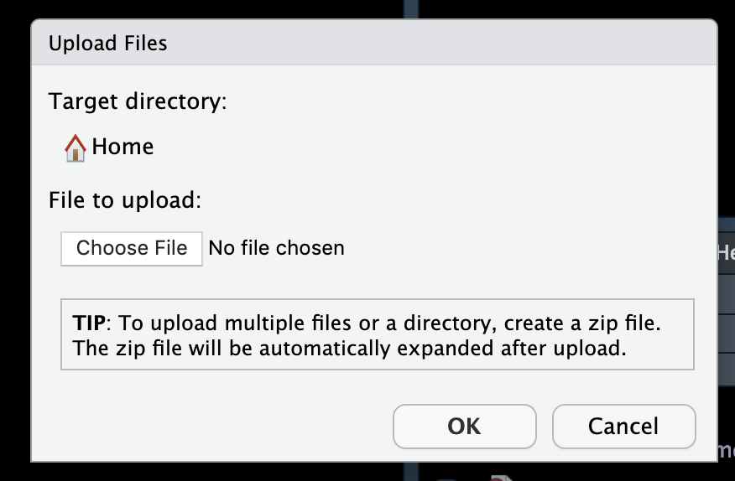

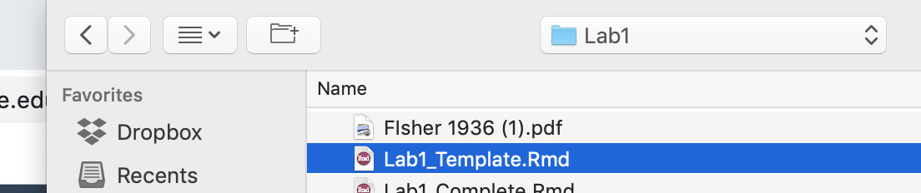

1. Double click on the Lab2_template file now in your file environment list, a blank lab template will open
2. Now let’s enter your code:
   1. Run Line 11 by highlighting the line and use Run Selected Lines. This is the help file associated with this function. What happened when you ran this line?

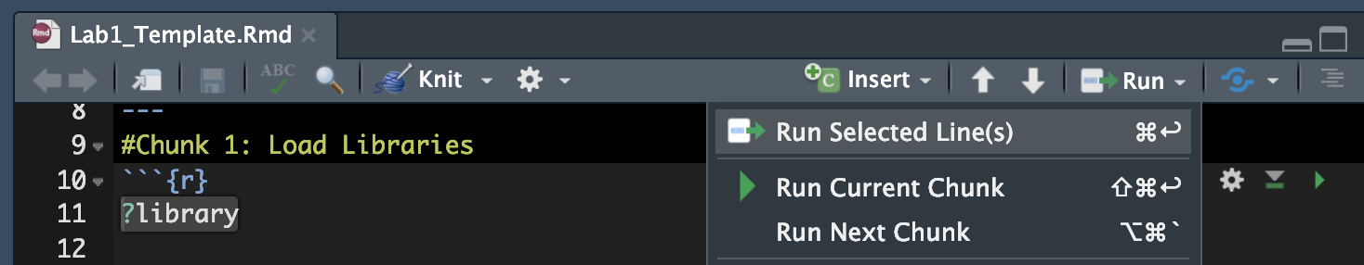

* 1. Load two libraries using the library() function on lines 12 and 13:
     1. ggplot2 & datasets
  2. Using a #; comment on two different arguments of the function `library`
  3. Close this chunk by using ``` on line 14

1. Skip a line and open a second chunk; call it “Load Data”
   1. Create a new chunk Label it “Load Data” using a level 1 header (# outside a chunk)
   2. Load a dataset from the datasets library using the data() function:
      1. The name of the dataset is “InsectSprays”
      2. When using names make sure these are placed in “ “
   3. Close the chunk
2. Skip a line and open a third chunk using ```{r}
   1. Explore the structure of the data you just loaded using the functions head(), str() and summary (), close the second chunk
   2. Close the chunk using ```
3. Skip a line open a fourth chunk; call it “My First Boxplot”
   1. build your first ggplot using the functions “ggplot” and “geom_boxplot” using the InsectSprays dataset
   2. Create a ggplot object using the function ggplot(data=, aes(x=, y=))
   3. On line 40 designate the type of plot you want to make in this case a box and whisker plot: geom_boxplot()
   4. Using a comment # describe the plot you see. What do the different lines mean?
   5. Close the chunk
4. Skip a line and open a fifth chunk; call it “Iris and Violin Plot”
   1. In this chunk load the dataset “iris”
   2. Create a violin plot for “Sepal.Length” where each species is colored differently, and the color fill is 50% transparent.
   3. Change the y axis label from “Sepal.Length to “Sepal Length (mm)”
   4. Close the chunk
5. Knit your markdown file: Knit/Knit to HTML (or Word) and name your file “Lab2_DATE_YOUR.LAST.NAME”). Click on “download file” when prompted

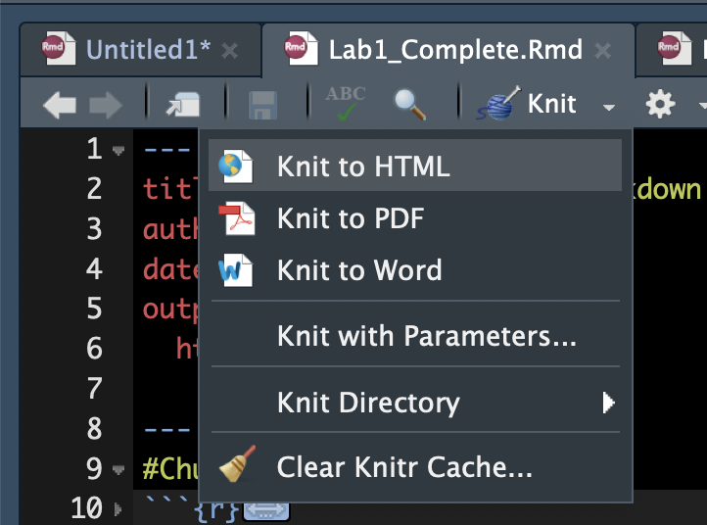

1. Submit this word document through Moodle “Lab 2”.